Dissipative Hamiltonian Neural Networks for Relativistic Spaceflight
  - Plain language derivations code explanation and comparison with the LNN baseline
JunXi Wu
October 2026
Main finding
The saved dissipative Hamiltonian neural network predicts the combined relativistic motion closely within its tested region. It does not recover a reliable physical separation between conservative motion and drag: the two learned component errors almost cancel. Its reported momentum-based velocity error is small, but its position-rate error is larger. These distinctions determine what the model can currently support as a research result.
This companion report derives the conservative and dissipative equations, explains how both neural networks use them, and evaluates the saved checkpoints. The emphasis is on phm_dhnn.py; the conservative phm_lnn.py model supplies the earlier baseline. Each equation is followed by its everyday meaning, and the performance discussion separates measured results from proposals for later experiments.

The spacecraft model and its variables
We model motion along one line with a fixed spacecraft mass. The drive supplies a constant force of m times a. In the conservative baseline this gives constant proper acceleration; after drag is added, a remains the force scale and the net proper acceleration is no longer constant. Drag removes momentum in whichever direction the spacecraft is moving.
Quantity | Value | Role
Speed of light c | 300000000 m/s | Relativistic speed scale
Acceleration scale a | 15 m/s squared | Sets force and time units
Fixed mass m | 100000 kg | Same baseline mass
Destination distance | 11.9 light years | Sets the comparison interval
Dimensionless drag strength | 0.02 | Illustrative training setting

The lowercase q is position measured in units of c squared divided by a. The letter s is Earth-frame time measured in units of c divided by a. Beta is velocity divided by c. The lowercase p is relativistic momentum P divided by m times c. Gamma is the relativistic multiplier, equal to one divided by the square root of one minus beta squared. A prime means a derivative with respect to s.
The half-trip distance is q = 9.382158 and the conservative half-trip time is s = 10.333887. The D-HNN evaluation uses that same time interval. With drag, the analytic spacecraft reaches q = 9.322308 at the endpoint, so the interval is a shared comparison duration rather than the actual arrival time of the damped craft.
The coefficient 0.02 has not been fitted to measured gas or dust. It corresponds to K = 3.333333 × 10⁻¹³ kilograms per meter under these scales. The code combines all smooth drag into this one constant and assumes a fixed mass. Fuel consumption, braking, radiation, discrete impacts and exhaust bookkeeping require further equations.

Deriving the conservative Lagrangian
The Lagrangian is a scalar rule from which we obtain the motion by differentiation. For a free relativistic particle it contains a square-root term. A constant forward force contributes a potential of minus force times position, so it enters the Lagrangian with a plus sign.
Divide the physical expression by m times c squared and add the constant one. The resulting dimensionless Lagrangian is the one in phm_lnn.py. Adding a constant changes the number assigned to the scalar but changes none of its derivatives, so it leaves the motion unchanged.
The Euler-Lagrange equation says that the rate of change of the momentum generated by the Lagrangian equals the position derivative of the Lagrangian. Here the position derivative is one, and the velocity derivative is gamma times beta. We call that velocity derivative p, the canonical momentum.
Differentiating p with respect to beta gives gamma cubed. By the chain rule, p prime equals gamma cubed times beta prime. Since p prime is one in the conservative case, divide by gamma cubed to obtain beta prime. At small speeds the acceleration is close to one in these units. Near the speed of light, the coordinate acceleration approaches zero.
This derivation uses the standard fixed-mass PHM Lagrangian from the earlier report. Its momentum is gamma times beta. The separate Downloads comparison prototype uses another kinetic Lagrangian and another momentum map; those prototype equations do not define the baseline analyzed here. The pairing between a Lagrangian and its canonical momentum must stay consistent.

Deriving the Hamiltonian

Changing the second coordinate from velocity to momentum
Momentum and velocity are almost proportional at low speed. Relativity makes their relationship nonlinear near c. A Hamiltonian model needs position and canonical momentum as its two physical coordinates. Squaring p = gamma times beta and solving for beta gives the conversion used by the D-HNN evaluation.
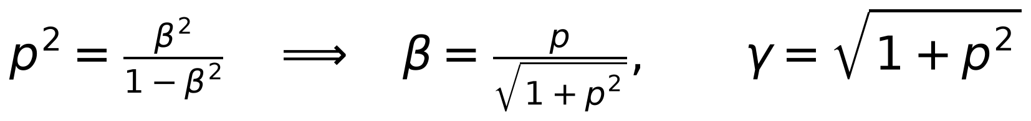
Keep the sign of p when taking the square root: negative momentum means negative velocity. The denominator grows with momentum, so the converted velocity remains strictly between minus one and one for finite p. This property belongs to the conversion formula; it does not by itself constrain a learned position derivative.

The Legendre transform
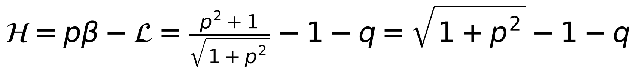
The Legendre transform multiplies momentum by velocity and subtracts the Lagrangian. Substitution replaces beta with p. The two kinetic terms combine into the square root of one plus p squared. The minus one removes the rest-energy offset, and the minus q records the potential associated with the constant drive force.
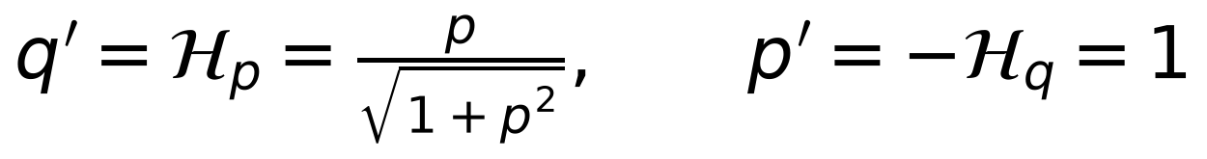
Differentiate H with respect to p to obtain the position rate. Take minus its q derivative to obtain the momentum rate. The same conservative physics now has a particularly simple momentum law: p grows at a constant rate. Starting at rest gives the exact solution below.
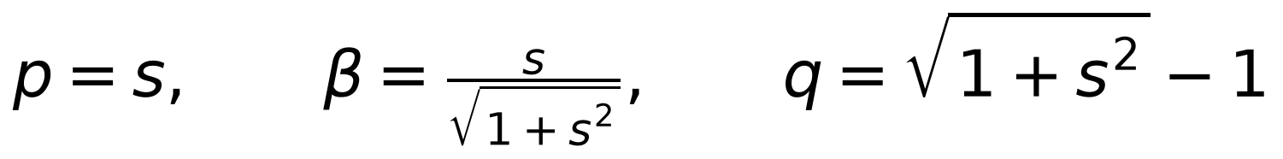
This Hamiltonian includes a constant-force potential. It represents a mathematical energy balance for that effective force field. It is not a complete model of an actual propulsion system and its fuel supply. To describe drive power and fuel explicitly, we would replace that bookkeeping choice with an external power port and a mass or reservoir equation.

Deriving relativistic drag
The earlier drag law says that the resistive force grows with velocity squared and an extra relativistic gamma-squared factor. The absolute value makes its direction correct: forward motion receives a backward drag force, and backward motion receives a forward one.
K combines gas and dust densities, their coefficients and the frontal area. The area is written as A with an area subscript here to avoid confusing it with the Python constant A, which stores the acceleration scale. This benchmark treats K as fixed.
The dimensional momentum is m times c times p, and dimensional time is c divided by a times s. Therefore dP/dt equals m times a times p prime. Divide the net force by m times a. The drive contributes one. The drag contributes minus kappa times gamma squared times beta times the absolute value of beta.
Because p = gamma beta and gamma is positive, gamma squared times beta times the absolute value of beta equals p times the absolute value of p. That identity turns the relativistic drag into a simple canonical momentum term. The position law still uses the relativistic velocity conversion.
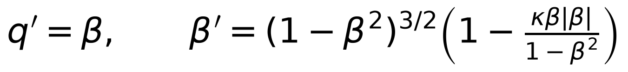
The last expression gives the same drag physics in the LNN coordinates q and beta. It follows by dividing the momentum equation by gamma cubed. It is the target a future forced LNN would need. The saved conservative LNN was trained on the zero-drag version, so it has not been evaluated as a competing drag model.

Two different dissipation functions

The classical Rayleigh function
A classical Rayleigh function is differentiated with respect to velocity, and the negative of that derivative supplies the drag force. To obtain it here, integrate the positive drag magnitude with respect to the magnitude of velocity. Substitute u = absolute beta into the integral.
The integral is artanh of u minus u because u squared divided by one minus u squared equals minus one plus one divided by one minus u squared. Multiplication by K times c cubed restores the physical units. Artanh is the inverse hyperbolic tangent. Differentiating the result produces the supplied drag law for both signs of velocity. Near zero speed, its leading term is K times the absolute value of velocity cubed divided by three.

The signed scalar used by this D HNN
The D-HNN code adds the ordinary gradient of its scalar D to the motion. Its scalar must therefore have a negative momentum derivative for positive p. Integrating minus kappa times p times its absolute value gives minus kappa times the absolute value of p cubed divided by three.
This signed momentum scalar and the positive classical Rayleigh function are different objects. The derivatives act on different coordinates, and their sign conventions differ. Simply replacing velocity by momentum in the classical Rayleigh formula would omit the coordinate-change factors. Both expressions are useful because their appropriate derivatives reproduce the same physical drag force.
The analytic function exact_dissipative_potential implements this signed scalar. It provides a reference for the derivation; training does not give its values to the neural network.

Combining the fields and deriving energy loss
The gradient of a scalar contains its position and momentum slopes. The matrix J swaps those two slopes and flips one sign. Applied to H, this produces the conservative pair consisting of velocity and forward momentum acceleration. Applied directly to D without J, the ordinary gradient supplies the drag pair: zero change in position rate and a resistive momentum rate.
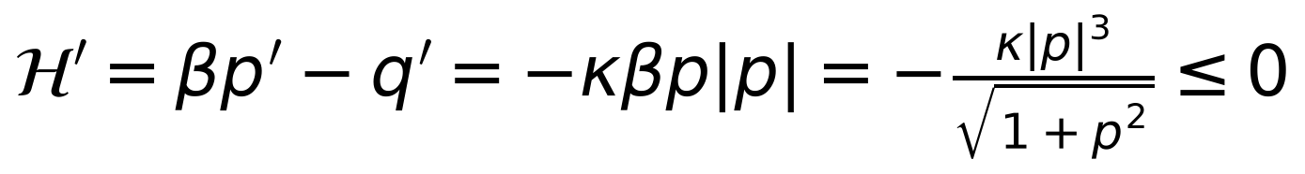
To derive the energy rate, differentiate H along the moving state. Its q derivative is minus one and its p derivative is beta, so H prime equals minus q prime plus beta times p prime. Substitute the exact position and momentum equations. The forward-drive terms cancel, leaving a nonpositive drag-loss term. It is zero at rest and negative whenever the craft moves and kappa is positive.
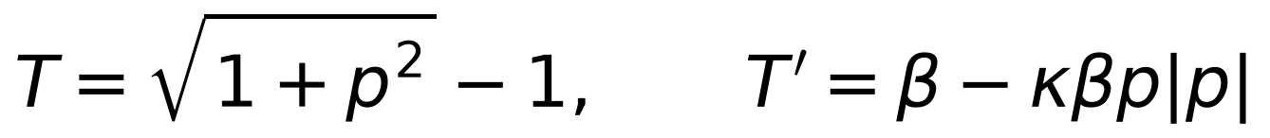
The spacecraft kinetic energy can still rise while this Hamiltonian falls. The drive supplies kinetic power beta in dimensionless units, and drag removes the second term. The potential minus q cancels the drive work inside H. A negative value of H therefore describes this chosen energy accounting; it does not mean the craft has negative kinetic energy.
For the learned model, the Hamiltonian field alone conserves its learned H, since a gradient has zero inner product with its symplectic rotation. Along the full D-HNN field, however, the learned energy changes according to the next expression.
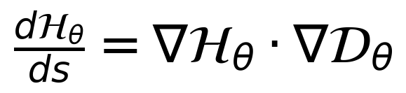
An unrestricted pair of neural scalar functions does not force this inner product to be nonpositive. The analytic drag law has the correct energy sign. The generic D-HNN architecture allows energy loss but does not guarantee that every learned state has physical drag or the right energy balance.

The analytic damped trajectory
For a spacecraft initially at rest, momentum becomes positive after launch. On this branch the momentum equation is p prime equals one minus kappa times p squared. Separating variables gives dp divided by one minus kappa p squared equals ds. Integrating gives artanh of square-root-kappa times p divided by square-root-kappa equal to s.
Taking the hyperbolic tangent gives the explicit momentum solution. The terminal momentum occurs where the drive and drag balance. Its corresponding velocity is one divided by the square root of one plus kappa. At kappa = 0.02, these limits are p = 7.071068 and beta = 0.990148. The trajectory approaches that terminal velocity rather than c.

Obtaining position from momentum
Divide q prime by p prime to obtain dq/dp = p divided by the product of square root of one plus p squared and one minus kappa p squared. Let u be square root of one plus p squared. Then p dp divided by square root of one plus p squared becomes du, and the remaining denominator becomes one plus kappa minus kappa u squared. Its integral gives the expression below.
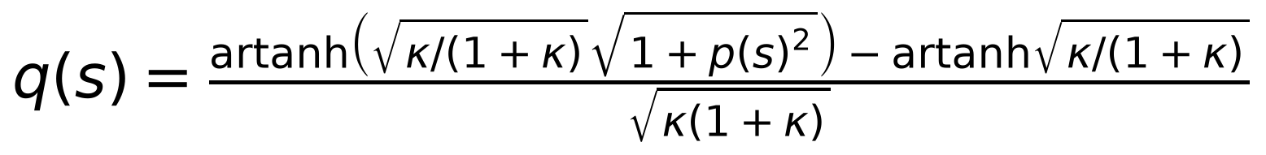
The subtraction sets q equal to zero when p is zero. This expression applies to the positive branch from rest with kappa greater than zero and momentum below the terminal value. In the zero-drag limit, the conservative solution is recovered.
The implementation obtains its reference path numerically with fourth-order Runge-Kutta rather than using this closed form. That keeps the rollout interface the same for analytic and learned fields. The analytic solution provides an independent way to check the solver. Both paths are evaluated for 500 sampled times from s = 0 to the original conservative half-trip time.

How the conservative LNN code works
The conservative LNN takes q and beta and passes them through a 128-unit layer, Softplus, another 128-unit layer, Softplus, and a one-number output. That output is the learned Lagrangian. Softplus is smooth, which matters because the equation of motion needs second derivatives of this scalar.
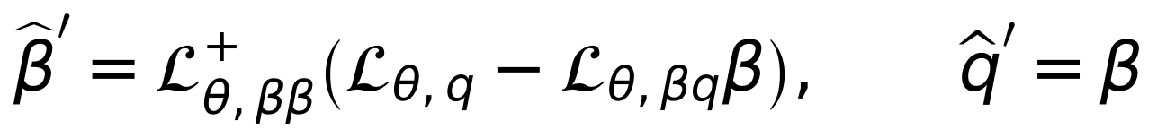
The Hessian with respect to velocity measures how quickly the learned momentum changes when velocity changes. In one dimension, the pseudoinverse acts like division by that curvature when it is nonzero. The position derivative supplies the driving term. The mixed velocity-position derivative subtracts the part of momentum change caused by moving through position-dependent scalar values.
q, q_t = jnp.split(state, 2)
q_tt = jnp.linalg.pinv(jax.hessian(lagrangian, 1)(q, q_t)) @ (
jax.grad(lagrangian, 0)(q, q_t)
- jax.jacobian(jax.jacobian(lagrangian, 1), 0)(q, q_t) @ q_t
)
return jnp.concatenate([q_t, q_tt])
In equation_of_motion, splitting state separates position from velocity. JAX calculates the derivatives exactly for the implemented network operations. The final returned pair is the supplied velocity and the computed acceleration. Consequently q prime equals beta by construction in this model, even when the learned acceleration is inaccurate.
learned_lagrangian wraps the network so it has the argument layout expected by equation_of_motion. loss applies the dynamics to every sampled state and compares the predicted derivative pair with the analytic labels. make_model builds the network and applies the tutorial initialization. train uses Adam and a three-stage learning-rate schedule. solve_lagrangian integrates the learned field; evaluate checks its trajectory and two energy measures.
A badly learned velocity curvature can make the division unstable. The LNN structure also does not force the true relativistic square-root expression. Its learned velocity may cross c even though its own learned energy remains conserved.

What the LNN baseline actually demonstrated
The earlier checkpoint was trained at absolute beta values up to 0.7, with testing extending from 0.7 to 0.9953505. This deliberately asks the model to predict beyond its training-speed range. The final training derivative MSE was about 1.3651 × 10⁻⁷, while its high-speed test MSE was about 1.0188 × 10⁻³, as recorded in the original baseline report.
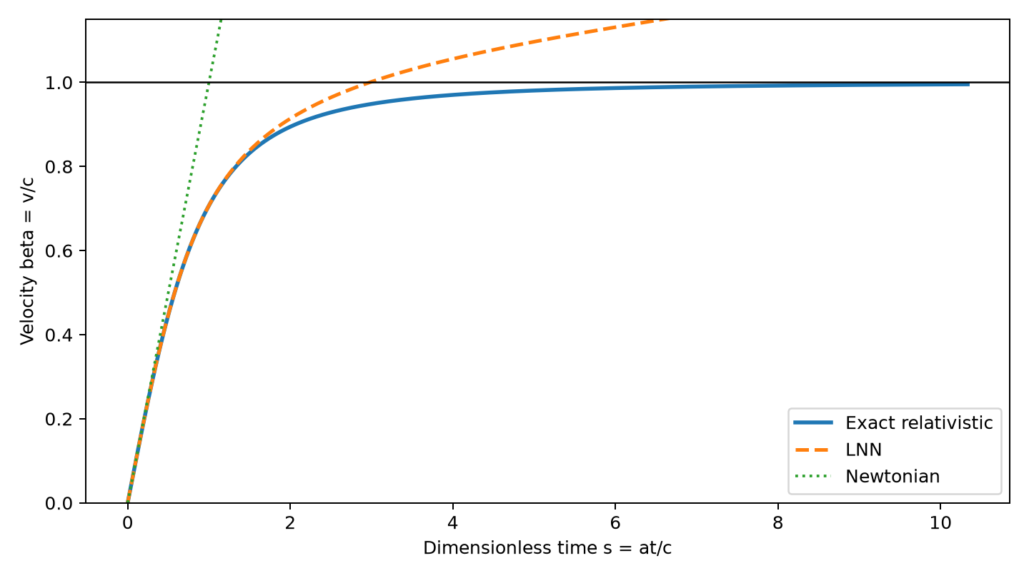
Figure 1 The conservative LNN path compared with its own conservative reference
The saved LNN has a trajectory velocity RMSE of 0.149344 c. It conserves its learned Hamiltonian to about 3.87139 × 10⁻⁷, but the true PHM Hamiltonian defect reaches 17.7677 before the relativistic formula becomes undefined. The original report records a first learned beta at least one near s = 2.9821.
The failure is a physical one: conserving the model’s own scalar did not make that scalar the right description of the spacecraft. The high-speed range was outside the training band, and integration accumulated the local errors. These observations establish a useful baseline limitation; they do not imply that all LNNs fail or that a D-HNN trained under different conditions has won a fair comparison.

How the D HNN scalar networks work
The D-HNN receives a batch of physical states x containing q and p. It appends a time column t to form three network inputs. In this experiment that time column is always zero. Each state is sent into two separate networks: mlp_h returns a Hamiltonian scalar, and mlp_d returns a signed dissipative scalar. The subnetworks have independent weights.
class MLP(nn.Module):
def __init__(self, input_dim, output_dim, hidden_dim):
super().__init__()
self.lin_1 = nn.Linear(input_dim, hidden_dim)
self.lin_2 = nn.Linear(hidden_dim, hidden_dim)
self.lin_3 = nn.Linear(hidden_dim, output_dim)
def forward(self, x, t=None):
inputs = torch.cat([x, t], dim=-1) if t is not None else x
hidden = self.lin_1(inputs).tanh()
hidden = hidden + self.lin_2(hidden).tanh()
return self.lin_3(hidden)
A linear layer forms weighted sums of its inputs and adds a bias. Tanh smoothly limits its output between minus one and one. The second hidden layer produces a correction added to the first hidden representation. This addition is the residual step. The final linear layer turns the hidden values into one scalar.
With width 256, each scalar network contains 67073 trainable parameters. The pair contains 134146 parameters. The time input permits the same interface as the reference code, but zero-time training does not teach a time-varying law. During rollout learned_field also passes zero rather than the current integration time.
The MLP architecture and the two-scalar construction match the authors’ public models.py implementation. The scalar values are not supplied as training labels: the objective uses their derivatives. Constant offsets in either scalar therefore cannot be determined from the motion data. [1, 2]

Turning the scalar outputs into motion
The Hamiltonian contribution swaps the input derivatives and negates the position derivative. The dissipative contribution uses its derivatives directly. Add the contributions to obtain the two predicted rates. DHNN.forward performs this entire calculation automatically.
dissipative_scalar, hamiltonian = self.scalars(x, t=t)
dissipative = torch.autograd.grad(
dissipative_scalar.sum(), x,
create_graph=create_graph, retain_graph=True
)[0]
hamiltonian_gradient = torch.autograd.grad(
hamiltonian.sum(), x, create_graph=create_graph
)[0]
d_h_dq, d_h_dp = torch.split(
hamiltonian_gradient, hamiltonian_gradient.shape[-1] // 2, dim=1
)
conservative = torch.cat([d_h_dp, -d_h_dq], dim=-1)
return dissipative + conservative
requires_grad tells PyTorch to track how each input affects the scalar. sum converts the batch of scalar outputs into one number whose gradient can be requested. Because this network processes each sample independently, the gradient at each row is still that row’s derivative. No batch-normalization or cross-sample operation mixes the rows.
create_graph=True keeps the derivative calculation available for further differentiation. Training needs that because the loss depends on input derivatives, and loss.backward must differentiate them with respect to the weights. Thus the motion uses first input derivatives, while training still differentiates through those derivatives. create_graph=False is sufficient for ordinary rollout inference.
retain_graph=True preserves the computation long enough for the second gradient request. as_separate=True returns the dissipative and conservative vectors individually so evaluate can measure their errors. The derivative is taken with respect to x, not the appended time column. For the saved configuration, omitting t would give the wrong number of network inputs.

Where the training labels come from
make_dataset creates a 25 by 25 rectangular grid in q and p, giving 625 physical states. Position runs from zero to the conservative half-trip distance. Momentum runs from minus 10.333887 to plus 10.333887. Equal spacing in p is not equal spacing in beta: near high momentum, a large momentum interval produces a small velocity change.
p = states[..., 1]
conservative = np.stack(
[beta_from_momentum(p), np.ones_like(p)], axis=-1
)
dissipative = np.stack(
[np.zeros_like(p), -float(drag) * p * np.abs(p)], axis=-1
)
return dissipative + conservative
analytic_vector_field supplies exact derivative labels from the derived equations. These are synthetic labels from the assumed physics, rather than observed spacecraft measurements. The function can also return the reference components separately. Those component arrays are retained for evaluation but are not used by train to supervise the decomposition.
A seeded permutation shuffles the grid. The first 80 percent, or 500 points, form the training set. The remaining 125 points form the test set. Both subsets cover the same broad rectangle. This is a held-out interpolation test across the momentum range, unlike the LNN’s separate high-speed extrapolation band.
start = (step * batch_size) % len(values)
batch = values[start : start + batch_size]
return torch.tensor(
batch, requires_grad=True, dtype=torch.float32, device=device
)
get_batch follows the reference code’s contiguous cyclic slice. A slice near the end can be shorter than 128; it does not wrap the missing rows around to the beginning. The data is shuffled once before training, rather than reshuffled each epoch. Float32 stores the values at the precision used by the neural model.
The third input t is a column of zeros. The grid covers both momentum signs, so the model sees drag opposing motion in either direction. The relativistic constants scale the labels into manageable numbers, but the inputs are not additionally standardized to zero mean or unit variance.

The loss and the training loop
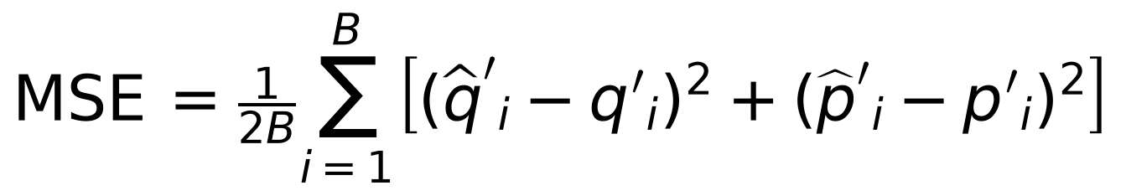
For each example, compare the predicted position and momentum rates with their labels, square the two differences, then average across all examples and both coordinates. The mean is divided by twice the batch size because there are two rate values per state. A smaller mean squared error means better local motion predictions.
optimizer = torch.optim.Adam(
model.parameters(), lr=args.learning_rate, weight_decay=0.0
)
for step in range(args.steps):
x, t, dx = [
get_batch(data[name], step, args.batch_size, args.device)
for name in ("x", "t", "dx")
]
prediction = model(x, t=t)
loss = (dx - prediction).pow(2).mean()
loss.backward(retain_graph=False)
optimizer.step()
optimizer.zero_grad()
Adam adjusts each weight using the recent gradients and their squared magnitudes. backward computes how the derivative errors change with every weight. step applies the update, and zero_grad clears the old gradients so they are not accidentally added into the next iteration.
The default run uses 5000 updates, learning rate 0.01, nominal batch size 128, hidden width 256 and seed 42. There is no learning-rate decay, component-label loss, boundary-condition loss, or weight-decay penalty. PyTorch and NumPy seeds are set, although bit-for-bit reproducibility across devices and library versions is not guaranteed.
Periodic testing occurs every 100 steps, and progress is normally printed every 200. The training test slice uses up to the first 128 test points; here there are only 125, so it includes the whole held-out set. The last periodic test is step 4900. The separate evaluate call recomputes the metric for the final saved weights after step 4999.
The saved checkpoint contains both subnetworks’ weights, the configuration, training history and a source reference. It stores the final weights rather than selecting whichever earlier test point had the lowest loss. This distinction matters because a fixed learning rate can cause temporary spikes even after the model has learned a good approximation. [3]

Training performance and fidelity to the study
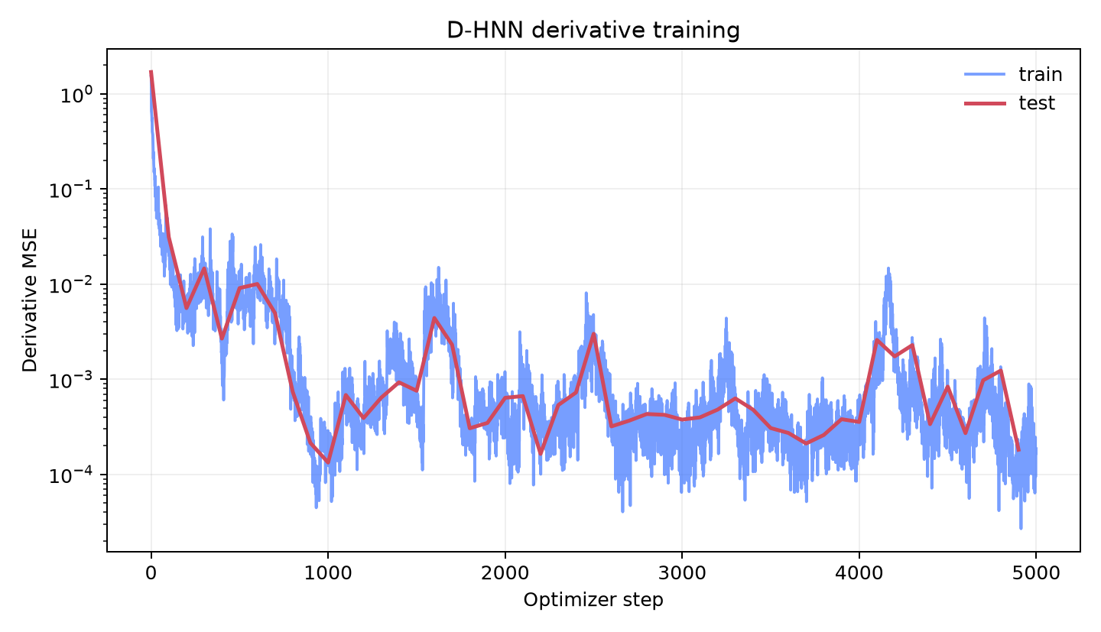
Figure 2 Derivative loss during the saved 5000 step D HNN run
The first training-batch MSE was 1.53057. The final training-batch MSE was 0.000186393, a reduction by roughly 8200 times. Those two batch values summarize optimization progress, but they are not whole-training-set errors. The final whole-test-set MSE was 0.000184054. The curve’s spikes reflect the actual recorded run.

What matches and what changes
The implementation preserves the public repository’s two residual tanh scalar networks, symplectic-plus-ordinary gradient construction, contiguous batching and derivative squared-mean loss. It also uses the synthetic-task width, optimizer settings, split and update count. [2, 3]
The spacecraft physics, state ranges and drag coefficient are project substitutions. The shuffled indices use NumPy’s newer random generator. This run uses a CPU rather than the study’s GPU. Evaluation uses fixed-step RK4 with 500 time samples, whereas the paper reports an adaptive Runge-Kutta evaluation. These differences mean this is a methodological adaptation, not a reproduction of the paper’s spring numerical results. [1]
The study’s experiments involve a damped spring, a real pendulum and ocean currents. The relativistic spacecraft experiment is the present project’s extension. No learned HNN, direct MLP or forced LNN was trained as a same-data baseline for this D-HNN run. Those comparisons remain separate work.

The learned trajectory and its measured accuracy
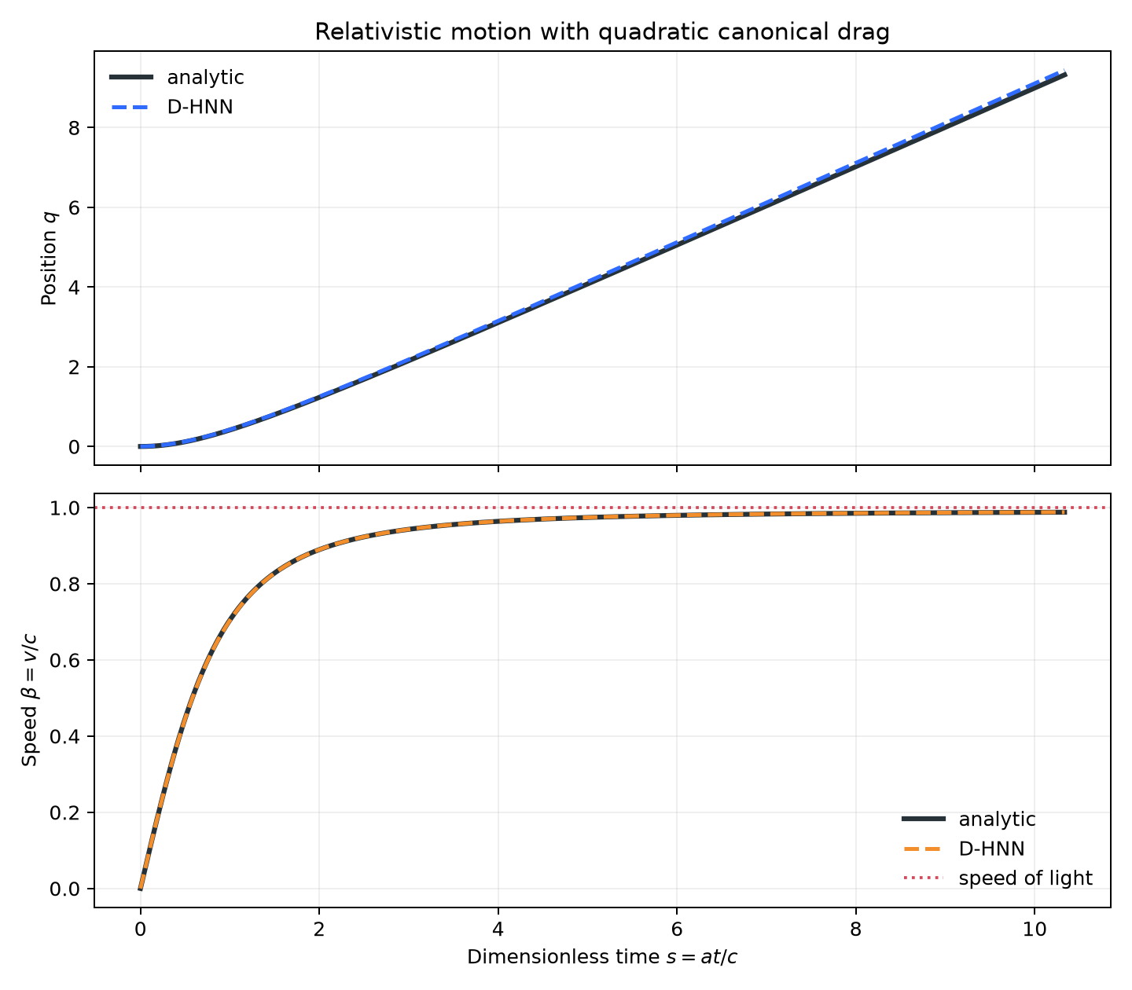
Figure 3 Analytic and learned paths over the shared conservative half trip duration
Measurement | Saved value | Meaning
Total test derivative MSE | 0.000184054 | Local combined-field fit
Position RMSE | 0.0676902 | Error in dimensionless q
Momentum-converted beta RMSE | 0.000312678 c | Velocity reconstructed from p
Analytic final q | 9.322308 | Reference endpoint with drag
Learned final q | 9.438652 | Predicted endpoint

RMSE is the square root of the average squared error: it reports a typical error magnitude in the original units. The position curves are close visually, but the final position is high by about 0.116344 q units. The reference and learned final momentum-converted velocities are 0.9878234 c and 0.9879208 c. This is encouraging behavior for this single checkpoint inside the tested state range. [5]

Checking what the plotted speed represents
In the saved evaluator, beta is computed from the learned p after integration. The model’s independently predicted q prime is not forced to equal that conversion. For a physically consistent trajectory, the position derivative and the momentum-derived velocity must agree. A narrow error in the second quantity can coexist with a larger error in the first.
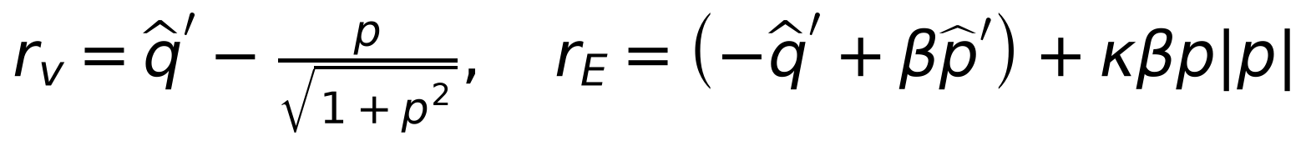
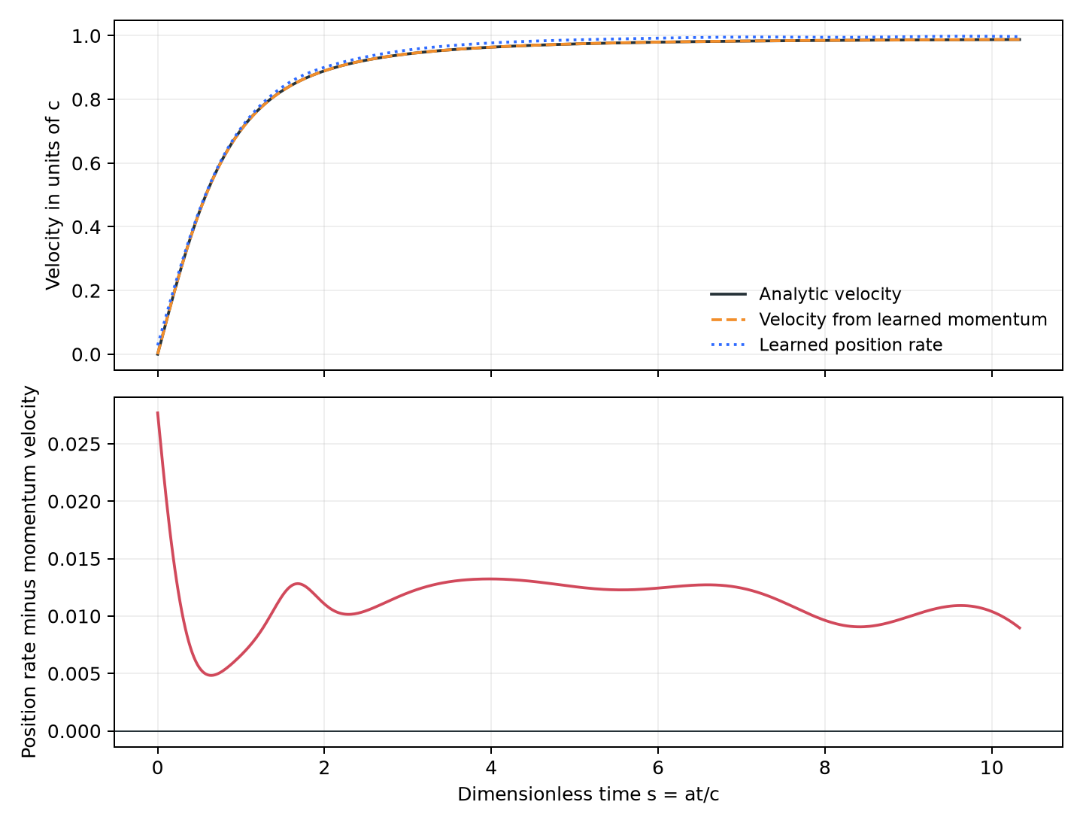
Figure 4 Momentum based velocity and the independently learned position rate
Additional checks of the unchanged checkpoint give a position-rate RMSE against the analytic velocity of 0.0115845 c, or about 3.48 million meters per second. The discrepancy between learned q prime and velocity inferred from its own p has RMSE 0.0115162 c. The quoted 0.000312678 c momentum-based error is about 93803 meters per second. These are different measurements of the same learned trajectory.
The maximum absolute learned position rate on this particular rollout was 0.998335 c. That trajectory remains below c, but the generic scalar networks impose no global speed bound on q prime. The conversion from finite p is bounded; the complete learned dynamics require their own check. [6]

Why a good total field can have a poor decomposition
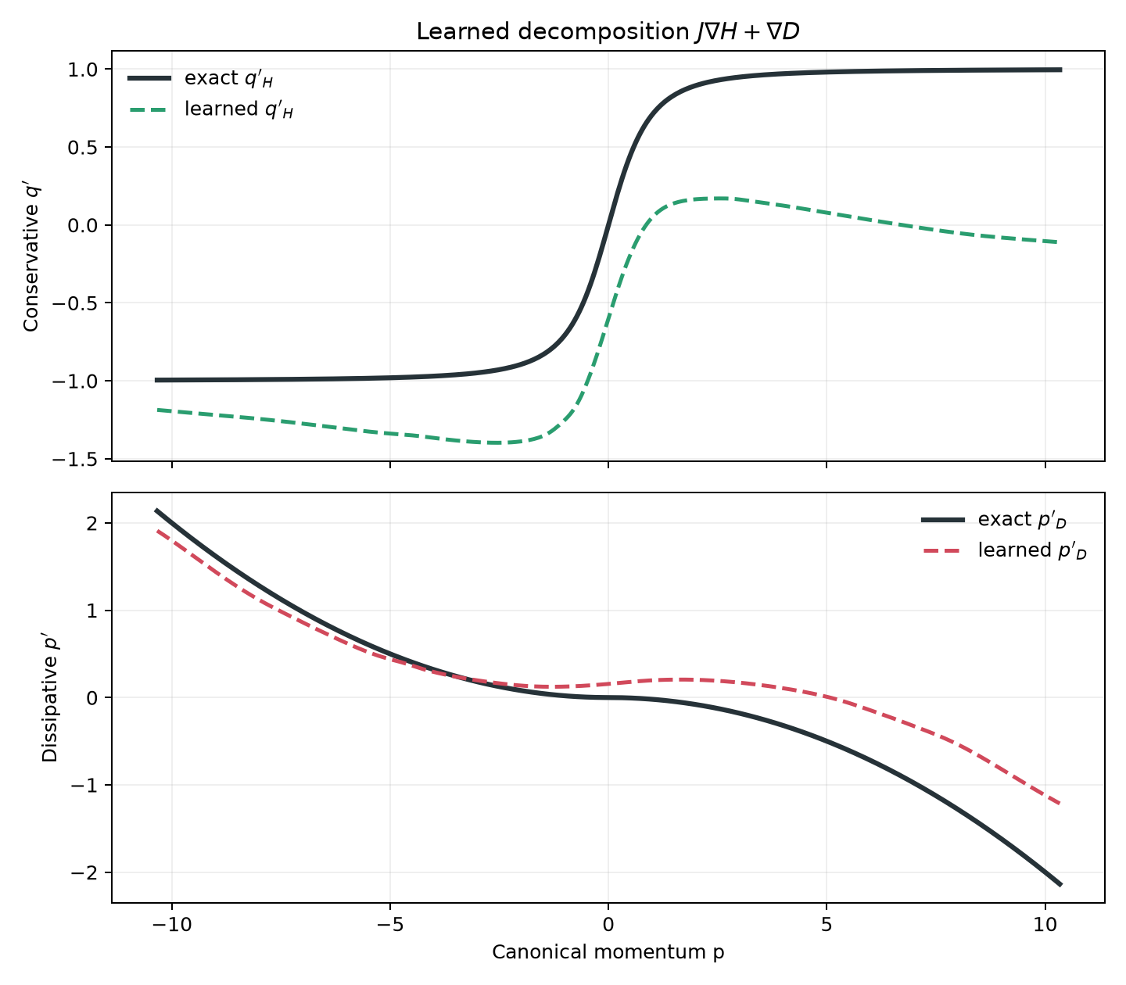
Figure 5 The learned conservative and drag components compared with their analytic references
The test MSE is 0.405715 for the conservative component and 0.410485 for the dissipative component, even though their sum has MSE only 0.000184054. The correlation between the conservative error and the negative of the dissipative error is 0.999666. A correlation close to one means the errors almost mirror each other and cancel when added. [5]
The component curves show that the learned scalars have not recovered the intended physical split. The network can still predict the total motion well because the training objective scores that sum. Scalar offsets alone would leave both component fields unchanged; the present problem is more serious because their derivatives also differ from the desired derivatives.
Calling every learned D contribution physical drag would therefore be unsupported. The current checkpoint is useful as a fit to the combined canonical field, while its components need additional identification conditions before they can be interpreted as the spacecraft’s actual energy and dissipation laws.

Deriving the ambiguity between the two scalars
The decomposition ambiguity can be demonstrated without referring to a neural network. Start with a pair H and D that already produces the correct field. Add alpha times q plus b times p to H. Add minus b times q plus alpha times p to D. These changes alter both component fields while leaving their sum exactly unchanged.
The change in the Hamiltonian field is the constant vector with components b and minus alpha. The change in the ordinary-gradient field is minus b and alpha. They cancel at every state. The derivative-only objective gives all these choices the same score, so it cannot determine how much of a constant drift or force belongs in each scalar.
The drive provides an especially clear example. H = square root of one plus p squared minus one minus q and D = minus kappa times absolute p cubed divided by three is the physical split used for reference. Another exact split omits minus q from H and adds p to D. The dissipative gradient then carries the entire constant drive contribution as well as drag.
There are also nonconstant cancellations. For example, adding q squared minus p squared to H and two q p to D produces cancelling vector fields. The first added scalar has zero Laplacian: its two second derivatives add to zero. Such harmonic terms account for freedom beyond a constant offset. The observed component errors need not be explainable by one constant-force shift.

What would identify a physical split
Boundary conditions, known conservative structure, component labels, or carefully chosen sign and coordinate restrictions can resolve some of this freedom. For this benchmark, fixing the relativistic Hamiltonian and learning a momentum-only drag scalar would make the intended split much clearer. That would be a new constrained model, rather than the current unrestricted two-network experiment.
The present implementation deliberately retains the total-derivative training objective. It reports the separate component errors instead of treating a close trajectory as evidence that both physical scalar laws have been discovered. The paper also recognizes the role of boundary conditions in uniqueness of a decomposition. [1]

Energy validation and its limits
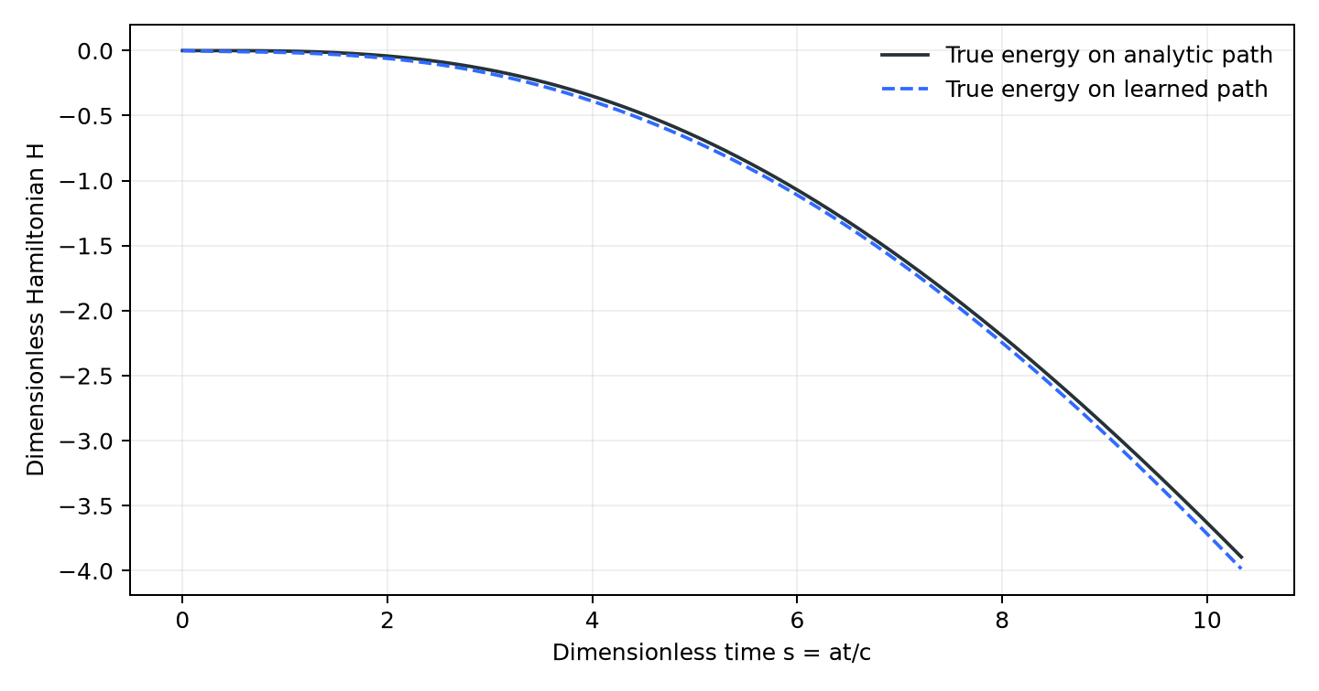
Figure 6 The true physical Hamiltonian evaluated on both paths
The exact-field reference loses energy monotonically over the sampled interval. Its largest one-step change is negative, about minus 9.20 × 10⁻¹⁰. The analytic_energy_balance_rmse saved by evaluate is 2.28578 × 10⁻⁵. That number compares a finite-difference derivative of the analytic path’s energy with its expected drag power. It validates the numerical reference and its energy law; it does not measure the learned model’s energy balance.
To assess the network itself, evaluate the gradient of the true H on its learned states and take its inner product with the learned vector field. Subtract the expected physical drag rate at those same states. The r_E residual defined alongside Figure 4 expresses this calculation. Its RMSE is 0.00826941 in dimensionless energy per unit s for this checkpoint. [6]
At the final time, the true Hamiltonian on the analytic path is minus 3.894715. The true Hamiltonian on the learned path is minus 3.985352. Their difference is about minus 0.0906363. The negative sign of the latter is not a fit error by itself; compare it with the damped reference and with the expected energy-rate law.
Because the networks are flexible and their decomposition is ambiguous, neither a falling true energy on one path nor conservation by the isolated Hamiltonian field proves that the learned H equals the physical Hamiltonian. A stronger evaluation would test energy-rate residuals over many initial states, report learned dissipative power signs, and refine the rollout time step to distinguish integration error from network error.

Comparing the LNN and D HNN fairly
Feature | Saved conservative LNN | Saved dissipative HNN
State | q and beta | q and canonical p
Learned scalars | One Lagrangian | Hamiltonian and signed D
Motion calculation | Second derivatives and pseudoinverse | First scalar gradients
Drag in training | None | Kappa = 0.02
Training region | Absolute beta at most 0.7 | Momentum through both signs of 10.3339
Test design | Separate high speed extrapolation | Shuffled holdout in same grid rectangle
Velocity metric | Learned beta state | Beta reconstructed from learned p
Position rate constraint | Equals beta by construction | Not tied to physical momentum conversion
Observed concern | Superluminal extrapolation and wrong physical energy | Component cancellation and rate inconsistency

The D-HNN’s momentum-based velocity error is much smaller in the recorded experiment. That numerical contrast cannot isolate the effect of model architecture. The D-HNN sees large momenta during training, while the LNN is asked to extrapolate into unseen high velocities. They also solve different force laws and report velocity differently.
A fair comparison would start from the same physical state samples, convert those beta values to canonical p for the HNN route, and train on the same drag law. It should test interpolation and extrapolation separately and score actual position rates as well as momentum-derived velocities. Matching training coverage matters more than matching only an update count.
Repeat across seeds and initial states, and include a forced LNN, a conservative HNN and a direct derivative MLP. Until those runs exist, the supported conclusion is that this D-HNN checkpoint approximates its own combined dissipative field well in the tested domain. The saved LNN illustrates a failure of a different conservative extrapolation experiment.

What the model structure can and cannot guarantee

Energy removal and a port Hamiltonian alternative
A port-Hamiltonian model can build dissipation into a matrix R whose quadratic form is nonnegative. That makes the first term in the energy rate nonpositive. The port Gu represents an explicit force or power input such as propulsion. Here R is a matrix; it is not the scalar D used in phm_dhnn.py.
The two-network D-HNN currently computes an ordinary gradient of a free scalar. It does not implement that positive-matrix restriction. For the known physical drag, one could choose a momentum damping entry proportional to kappa times absolute p times square root of one plus p squared. Multiplying that entry by H_p produces kappa p absolute p, the required momentum drag. This is a possible later constrained formulation.

Changing spacecraft mass
Let mu be mass divided by the initial mass. Momentum then includes mu as well as gamma and beta. Differentiation gives two terms: acceleration at the present mass, and momentum change caused by changing mass. The present two-state model has no mu equation and cannot account for exhaust or fuel merely by changing a constant in a checkpoint.
A mass-changing model needs an equation for mu prime and an explicit definition of thrust, exhaust momentum and energy exchange. Its kinetic energy has the square root of p squared plus mu squared, with a consistent choice of rest-energy reference. Time dependence or another state is required to track the mass and energy reservoirs.

Dissipation in phase space
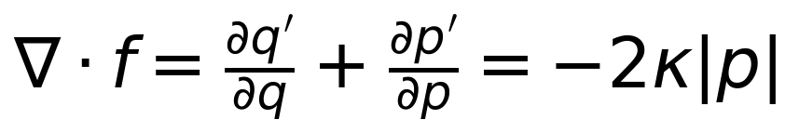
The divergence sums how the field’s position rate changes with position and its momentum rate changes with momentum. For the exact model it equals minus two kappa absolute p, so small neighboring regions in phase space contract except at p = 0. The isolated Hamiltonian field has zero divergence. This is another check of dissipative behavior, although the current metrics file does not report a learned divergence error.

The remaining code and reproducible commands
beta_from_momentum converts p into the relativistic velocity. exact_hamiltonian evaluates the known physical scalar; it is used to judge paths rather than directly supervising mlp_h. exact_dissipative_potential supplies the analytic signed drag scalar. make_dataset and get_batch assemble the examples described earlier. train builds the model, updates weights and saves the checkpoint.
load_checkpoint rebuilds the architecture from the stored dimensions, restores the weights, places the model on the CPU and sets evaluation mode. The checkpoint is a PyTorch object and should be loaded from a trusted local source. learned_field wraps the model as a function accepting one two-number state and returning its two rates.
rk4 computes four rate estimates per integration step: at the start, at two intermediate trial states, and at the end. Their weighted average updates the state. evaluate compares whole-test-set fields, integrates reference and learned paths, calculates metrics, and writes loss, trajectory and decomposition figures. check_physics verifies analytic gradients and the drag energy sign, plus a model output-shape check; it is not a learned-accuracy acceptance test.

Commands from the project root
python3 phm_dhnn.py --check
python3 phm_dhnn.py --evaluate
Use the Python environment with PyTorch, NumPy and Matplotlib installed. requirements_dhnn.txt adds PyTorch to the baseline dependencies. The earlier LNN environment already supplies JAX and Matplotlib but may need PyTorch added before it can run the D-HNN.
python3 phm_dhnn.py --train --steps 5000 \
--checkpoint results_dhnn/run_seed43/phm_dhnn.pt \
--output-dir results_dhnn/run_seed43 --seed 43
A new run with an explicit checkpoint and output directory preserves the current saved result. The default train command uses results_dhnn/phm_dhnn.pt and replaces that checkpoint. Evaluation loads the configuration from the checkpoint; adding a different --drag value to --evaluate does not change the stored model’s drag physics. To learn a new drag setting, train a separately named run with that coefficient.
The existing code does not provide a command that rescales the learned dissipative component during evaluation. Such a counterfactual would also need a verified physical decomposition. In this checkpoint, rescaling an incorrectly identified D field would change more than drag.

Evidence and research conclusions
The derivation connects the earlier fixed-mass Lagrangian to a canonical Hamiltonian and a drag field that admits a signed scalar potential. The implementation follows the two-scalar D-HNN construction and the reference training pattern. It completed 5000 updates and produced a checkpoint whose total derivative predictions and momentum-based trajectory velocity are close to the benchmark reference.
The saved model has three distinct limitations demonstrated by the measurements: its separate fields differ substantially from the physical split, its position rate differs from the velocity inferred from its momentum, and its learned-field energy residual is larger than the analytic reference’s numerical residual. These findings make the experiment useful for evaluating both predictive fitting and physical interpretation.
The next controlled experiment should use matched physical samples and a forced LNN comparator, distinguish actual position-rate error from converted momentum error, and evaluate component identification under stated boundary or structural constraints. Multiple seeds and integration-step refinements would establish whether the current single-run behavior is stable.

Sources and measurement provenance
1 Sosanya and Greydanus 2022
Dissipative Hamiltonian Neural Networks: Learning Dissipative and Conservative Dynamics Separately. Theory, methods and experimental scope.
2 Authors model implementation
greydanus/dissipative_hnns/models.py. Residual tanh subnetworks and gradient construction.
3 Authors training implementation
greydanus/dissipative_hnns/train.py. Optimizer, derivative squared-mean loss, cyclic slicing and default training configuration.
4 Conservative project evidence. phm_lnn.py; results/metrics.json; the existing Final Research Final.docx, including its earlier PHM derivations and saved LNN training values. The companion derivations use that same fixed-mass canonical momentum.
5 Dissipative project evidence. phm_dhnn.py; results_dhnn/phm_dhnn.pt; results_dhnn/metrics.json; the three saved figures. The evaluated checkpoint uses seed 42, grid size 25, width 256, 5000 steps and kappa = 0.02.
6 Additional checkpoint diagnostics. Evaluated on 500 states from the same learned RK4 trajectory over s = 0 to 10.333887. They compute the model position rate directly, compare it with momentum-converted velocity, and form the true-Hamiltonian energy-rate residual. No weights or training labels were changed for these checks.

